- Create a folder called learn_git_again.
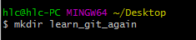
- Cd (change directory) into the learn_git_again folder.
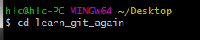

- Create a file called third.txt.
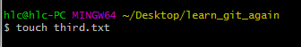
- Initialize an empty git repository.
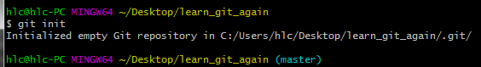
- Add third.txt to the staging area.
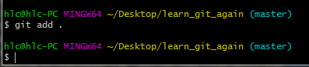
- Commit with the message "adding third.txt".
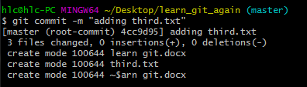
- Check out your commit with git log.
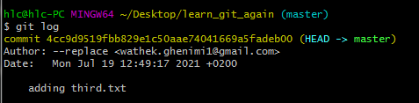

- Create another file called fourth.txt.
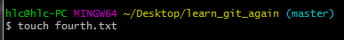
- Add fourth.txt to the staging area.

